**HR Analytics-Absenteeism**

**Wireframe documentation**

1. This image shows an HR Analytics dashboard focused on employee absenteeism. It displays various metrics and charts, including total employee count, average age, length of service, and absent hours. The dashboard also breaks down data by city, department, gender, job title, and age group, providing a comprehensive overview of workforce attendance patterns.

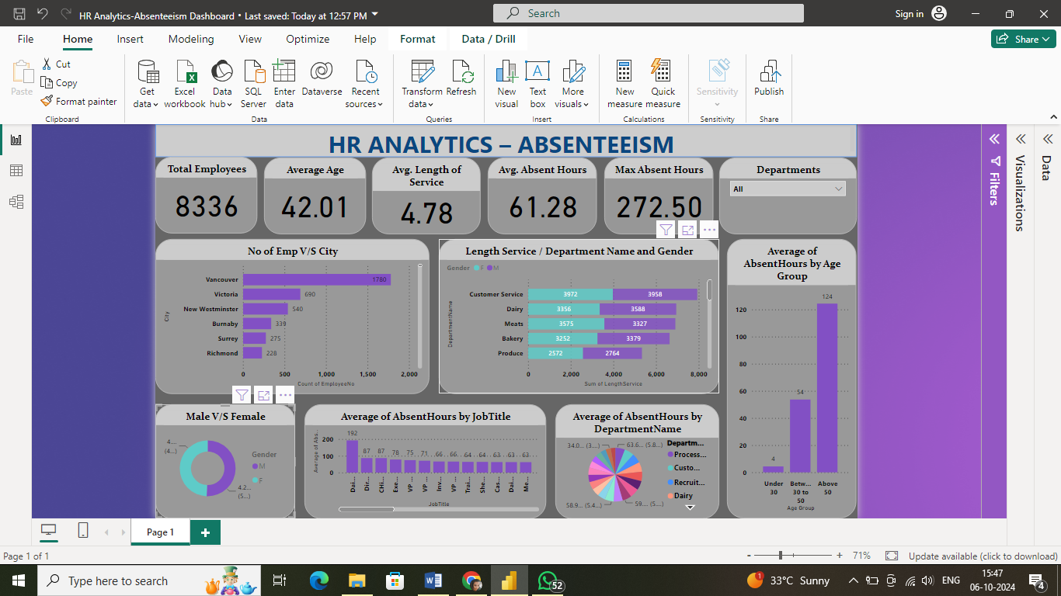

1. This section of the HR Analytics dashboard displays key metrics for employee absenteeism. It shows a total of 8336 employees with an average age of 42.01 years. The average length of service is 4.78 years, with employees averaging 61.28 absent hours and a maximum of 272.50 absent hours recorded.

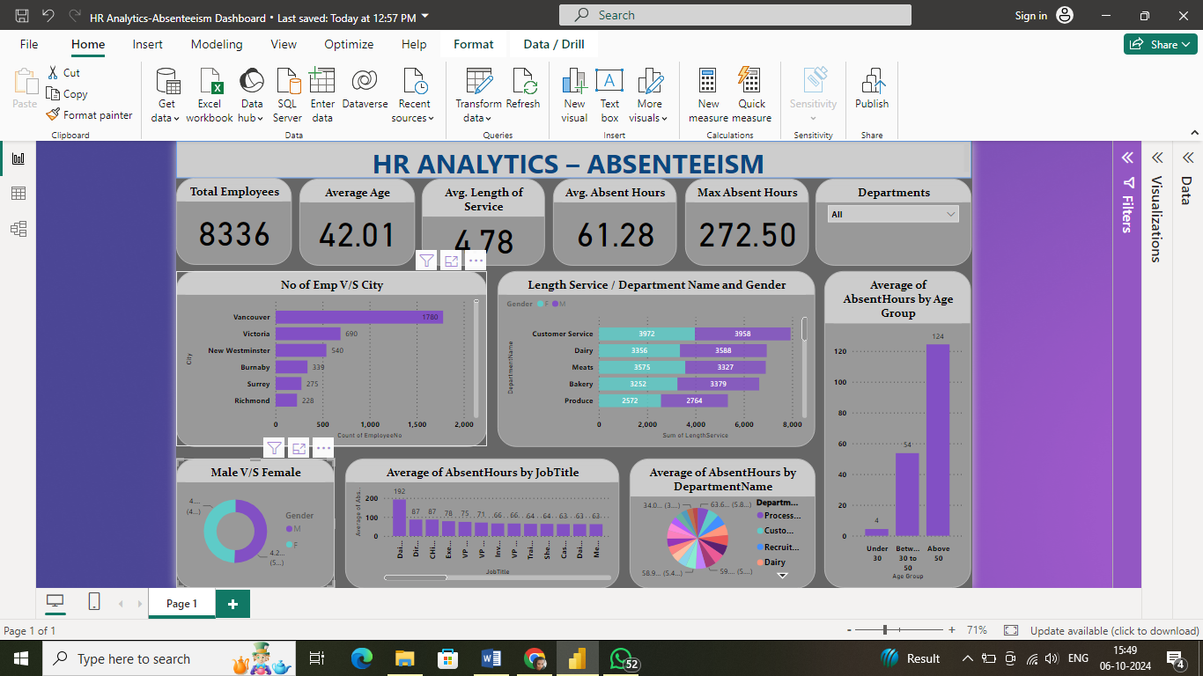

1. This HR Analytics dashboard shows absenteeism data for the Accounting department. It presents key metrics like employee count (18), average age (42.33), and absent hours (41.09 avg, 103.70 max), along with breakdowns by city, gender, job title, and age group, offering a comprehensive view of attendance patterns in Accounting.

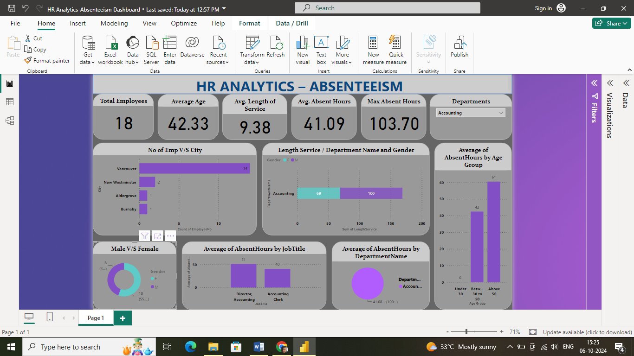

1. This HR Analytics dashboard displays absenteeism data for all departments, covering 1780 employees with an average age of 42.06 years. It shows various metrics including average absent hours (59.78) and breakdowns by city, department, gender, job title, and age group, providing a comprehensive overview of workforce attendance patterns across the organization

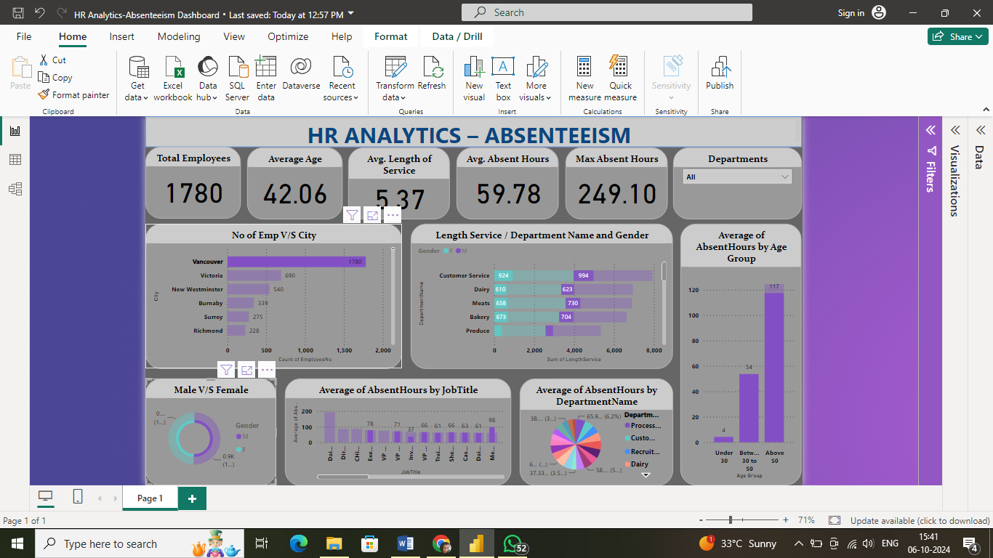

1. This HR Analytics dashboard shows absenteeism data for 4,120 employees with an average age of 41.30 years. It displays key metrics like average length of service (4.78 years) and average absent hours (66.69), along with breakdowns by city, department, gender, job title, and age group.

